**Web-Based Purchase Order Management System**

**A Project Presented to the Department of Computer Science in Partial Fulfillment of the Requirements for Bachelor of Science Degree Program**

**Table Of Content**

CHAPTER - I 1

1. Introduction 1

1.1. Background of the Organization 1

1.2. Statement of the Problem 2

1.3. Objectives of the project 3

1.3.1. General objectives 3

1.3.2. Specific objectives 3

1.4. Methodology 4

1.4.1. Data collection 4

1.4.2. System Development Process Model 4

1.4.3. Design Pattern 6

1.4.4. Programming Language 6

1.5. Tools 7

1.5.1. Hardware Tools 7

1.5.2. Software Tools 7

1.6. Scope and limitation of the project 8

1.6.1. Scope of the project 8

1.6.2. Limitations of the Project 9

1.7. Significance of the Project 9

1.8. Feasibility Study 11

1.8.1. Technical Feasibility 11

1.8.2. Operational Feasibility 11

1.8.3. Economic Feasibility 12

1.8.4. Legal Feasibility 13

1.8.5. Schedule Feasibility 13

1.8.6. Environmental Feasibility 13

1.9. Risk Assessment 14

1.9.1. Risk 14

1.9.2. Risk assumption 15

1.9.3. Constraints 16

1.9.4. Operational Significance 17

1.9.5. Financial Significance 17

1.9.6. Strategic Significance 17

1.9.7. Environmental Significance 17

1.10. Beneficiaries of the Project 18

1.10.1. Employees Across All Sites 18

1.10.2. Suppliers 18

1.10.3. Management and Decision-Makers 18

1.10.4. Customers of Upper Awash Agro Industry 19

1.10.5. The Environment and Society 19

1.11. Organization of the Project 19

1.12. Work plan 20

CHAPTER - II 22

2. Business Area Analysis and Requirement Definition 22

2.1. Introduction 22

2.2. Business Area Analysis 22

2.2.1. Detailed Analysis 23

2.2.2. Current system 23

2.2.3. Players of the Existing System 23

2.2.4. Proposed System 23

2.2.5. Forms and Reports Used 23

2.3. Requirement Gathering 23

2.3.1. Requirement Gathering Techniques 23

2.4. Methods of Communication 23

2.4.1. Common Techniques 23

2.5. Requirement Definition 23

# CHAPTER - I

# Introduction

The advancement of technology has revolutionized the way organizations handle their internal processes. One critical internal process is the management of purchase requests and orders. Many organizations still rely on traditional methods such as paper-based or email-based ordering, which can lead to inefficiencies, delays, and errors. A web-based purchase ordering system offers a streamlined solution, providing businesses with a digital platform to create, manage, and track purchase orders in real time.

This project proposes the development of a web-based purchase ordering system for *Upper Awash Agro Industry,* which will automate the procurement process, providing a user-friendly interface for submitting, approving, and tracking purchase orders. The system will reduce errors, improve process efficiency, allow for transparency, and offer data analytics for better decision-making.

## Background of the Organization

Upper Awash Agro Industry Enterprise is a prominent agricultural company based in Ethiopia. The establishment of the company can be traced back and attributed to 4 farms during the rule of *Emperor Haile Selassie, Melka Awara* Farm Development (*est 1904*), *Nura Hera* Farm Development (*est 1956*), Tibla Farm (*est 1957*), and *Merti* *(est 1963)*. After the fall of the Emperial rule, Derg regime took control over all four farms in 1972 and started operating them as one entity under the name of Nura Hera Farm Development. Since then the company have changed it’s name, product, and ownership throughout the years. Currently It’s owned and operated by MIDROC Investment Group.

Currently Upper Awash Agro Industry operates farms in two zones: East Shewa, specifically in the Bosset district, and in the Arsi zone, covering the Merti and Jeju districts with a branch and administration office in Addis Ababa. The company is primarily involved in the production and processing of a diverse range of agricultural products, including:

* Fresh and processed fruits and vegetables
* Cereals
* Cut flowers
* Seeds
* Fiber crops

The company currently employs over 7,000 individuals, including full-time, contractual, and seasonal workers. Monthly payroll expenses exceed 14 million Birr. In the 2014 Ethiopian Calendar year, the company paid over 150 million Birr in revenue tax. Additionally, the company demonstrates its commitment to social responsibility by donating over 10 million Birr annually.

## Statement of the Problem

Upper Awash Agro Industry operates across multiple locations, including rural farms, processing plants, and urban offices. The company relies on a steady supply of goods to support its operations. Currently, all purchase requests must go through the head office in Addis Ababa for approval. While this centralized system ensures oversight, it creates delays and inefficiencies, disrupting operations and increasing costs.

The procurement process is slowed by manual workflows and poor communication systems. Remote sites struggle to generate purchase requests, relying on outdated methods such as manual forms or poorly integrated communication channels. This process is prone to errors and delays, especially when incomplete or unclear requests require repeated clarifications.

Centralized approval creates a major bottleneck as all requests must be reviewed by the general manager in Addis Ababa, regardless of urgency or complexity. This overload causes delays even for routine purchases, while urgent needs, such as perishable goods or spare parts, often face critical delays. Additionally, the lack of a systematic method to prioritize requests leads to disruptions, as essential items may not be addressed promptly.

The collection of proforma invoices introduces further delays and inefficiencies. Staff often need to physically visit suppliers or rely on fragmented communication channels to obtain quotes, a process that is both time-consuming and labor-intensive. Suppliers may also delay responses, especially when requests are unclear. If initial invoices are rejected or additional quotes are needed, the process must be repeated, wasting time and resources.

These inefficiencies disrupt operations, as delays in procuring essential goods can halt farm activities, interrupt processing schedules, and impact office functions. Emergency purchases to address these delays often come at higher costs, further straining budgets. The reliance on manual processes also increases administrative workload, adding to overall expenses.

The prolonged procurement process strains supplier relationships. Delays in finalizing deals, especially when proforma invoices are only valid for a short period, frustrate suppliers and weaken partnerships, reducing the company’s ability to negotiate favorable terms. Employees at remote sites also feel powerless and frustrated due to the lack of autonomy and delays in addressing their needs.

The current system limits the company’s ability to adopt modern technology that could streamline procurement activities. Manual processes make scaling operations difficult as the company grows. The lack of transparency and centralized tracking also creates risks of unethical practices, as approvals and transactions are harder to monitor effectively.

## Objectives of the project

### General objectives

To develop a digital purchase requesting and ordering system that streamlines procurement processes, reduces delays, enhances transparency, and improves the overall efficiency of purchasing operations at Upper Awash Agro Industry by replacing the traditional manual paper-based system.

### Specific objectives

1. To improve the efficiency of purchase requests and approvals.
2. To integrate supplier engagement for streamlined operations.
3. To implement digital audit trails to log all procurement activities, including request submissions, approvals, and transactions, ensuring accountability.
4. To reduce delays and operational disruptions.
5. To facilitate user-friendly access across locations.
6. To promote environmental sustainability by reducing paper usage.

## Methodology

### Data collection

The data collection methodology will involve gathering information about the current procurement processes, identifying inefficiencies, and understanding user requirements for the proposed system. We plan to use several methods to collect the required data, to brainstorm solutions, and to help us develop approaches that stakeholders approve of and wish to see incorporated into the proposed system. These methods include :

1. **Interviews:** We held interviews with key stakeholders, including procurement staff, department heads, and few suppliers, to gather qualitative insights into main points and expectations.
2. **Observation:** We plan to observe the current procurement workflows to document how requests are processed, approved, and executed. This will allow us to identify delays or inefficiencies. While certain processes and documents might not be available for direct observation due to authorization constraints, we will work closely with stakeholders to obtain a clear understanding of those operations.
3. **Document Analysis:** We plan to analyze past purchase records, approval forms, and correspondence to understand data volumes, processing times, and error frequencies in the current system. This analysis will provide a quantitative foundation for identifying critical improvement areas.
4. **Workshops:** We hope to organize workshops with stakeholders to brainstorm solutions, discuss possible system features, and validate the requirements. These workshops will serve as a platform to align all participants on the system's objectives and functionalities.

### System Development Process Model

System development process models are structured approaches that provide frameworks for planning, creating, testing, and deploying software systems. For this project, we chose the Incremental Development Model.

The Incremental Development Model emphasizes breaking the system into smaller, manageable components that are developed, tested, and delivered in incremental stages. This approach allows us to build the system step by step while continuously refining and improving each module as new increments are added.

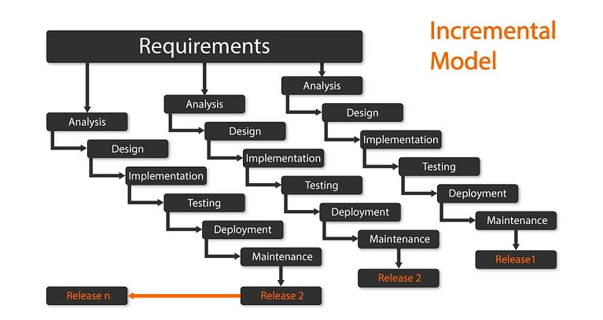

*Image 1. Incremental Model*

The Incremental Development Model was chosen for our Purchase Order Manaagement system due to its ability to address changing requirements while maintaining steady progress. Since the system’s requirements may evolve based on our advisor’s input and user feedback, this model provides the flexibility to incorporate changes without disrupting the overall development process. Each increment delivers a functional module of the system, allowing stakeholders to review and validate the progress at regular intervals.

This model is particularly suitable for our project as it helps reduce risks by enabling early detection of issues within individual increments. By focusing on smaller, manageable parts of the system, we can ensure that each module is thoroughly tested and optimized before integration. The step-by-step approach also supports ongoing learning and adaptation, which is especially valuable in an academic setting where team members are still gaining experience in software development.

With a team of four developers, the Incremental Development Model promotes effective collaboration by dividing the workload into clear, actionable goals. Each team member can focus on a specific increment, ensuring parallel development and faster progress. Additionally, delivering functional components incrementally allows us to present visible progress to our advisor facilitating timely feedback and alignment with project objectives.

Overall, the Incremental Development Model provides a structured yet flexible framework that aligns with the dynamic nature of our project, accommodates changing requirements, and ensures consistent progress toward a fully functional system.

### Design Pattern

The Model-View-Controller (MVC) design pattern was chosen for the project. This pattern separates the application into three interconnected components: the Model (data management), the View (user interface), and the Controller (business logic and user input handling).

The MVC pattern ensures a clear separation of concerns, making the system easier to develop, test, and maintain. It supports scalability and allows for independent development of components, which is crucial for a system as complex as procurement management. For instance, the Model can be developed to handle database interactions while the View focuses on delivering a user-friendly interface.

### Programming Language

|  |  |  |
| --- | --- | --- |
| **Components** | **Programming Language/Frameworks** | **Reason For Selection** |
| Front-end Development | HTML, CSS, JavaScript | Ensures a responsive and interactive user interface. |
| Framework | Laravel | Provides robust features for dynamic and scalable designs. |
| Back-end Development | PHP | Widely used, well-documented, and compatible with Laravel. |
| Database Management | SQL/SQLite | Efficient for structured data storage and supports complex queries. |

## Tools

### Hardware Tools

|  |  |
| --- | --- |
| **Devices** | **Description** |
| Personal Computers | Used for coding, testing, and designing the web app; includes desktops or laptops. |
| Mobile Devices | Used for testing the app's responsiveness and performance on smaller screens. |
|  |  |
| Storage Devices | External hard drives or cloud storage for backups and storing large datasets. |

### Software Tools

|  |  |
| --- | --- |
| **Softwares/Tools** | **Description** |
| Visual Studio Code | Programming language for backend and frontend development. |
| Microsoft SQL | Relational database management systems for storing procurement data. |
| Chrome, Edge | For testing and debugging the app's performance on different browsers. |
| Visio, Draw.io, PlantUml | Tools for creating diagrams like class diagrams, ER diagrams, and workflows. And also for UI prototyping |
| Github | For version control and colaborative development |
| Figma, Canva | Prototyping tools |
| WhatsApp, Telegram | Communication, file sharing, video conference tool |

## Scope and limitation of the project

### Scope of the project

The scope outlines the boundaries of the project, including what will and will not be covered.

* **Where it works:** The system works across various organizational locations, including farms, processing plants, and corporate offices.
* **For whom:** It is designed for Supply and Logistics unit members, procurement teams, departmental heads, and suppliers involved in the procurement process.
* **When:** It facilitates procurement activities during regular business operation hours and ensures real-time updates.
* **On what platform:** The system is web-based with a mobile-friendly interface for accessibility from both urban and remote locations.
* **Included expected MAIN features:**
  + Core Functionalities:
    - Digital submission of purchase requests.
    - Workflow automation for approvals and prioritization.
    - Integration with suppliers for proforma invoice submissions and comparisons.
    - Real-time tracking of requests and orders.
    - Reporting and analytics for procurement activities.
  + Accessibility:
    - Role-based access control for secure data handling.
  + Data Management:
    - Centralized database for procurement records.
    - Archiving and audit trails for compliance.
  + User Support:
    - Training sessions for employees and suppliers.
    - Help-desk support for troubleshooting issues during and after implementation.

### Limitations of the Project

* Features that are not covered by our project
* Advanced AI-driven procurement decision-making tools.
* Hardware procurement such as computers or networking equipment.
* Other unrelated business operations like Inventory Management, Marketing, or HR processes.
* Where does it not work?
* Locations with unreliable or no internet connectivity.
* When doesn't it work?
* During internet outages or periods of insufficient connectivity.
* Who cannot use it?
* Suppliers or employees who are not technologically adept or unwilling to adapt to the system.
* On what platforms can a user not use it?
* Platforms other than web or mobile, such as standalone desktop-only environments or legacy systems.

## Significance of the Project

The implementation of a digital purchase requesting and ordering system for Upper Awash Agro Industry offers critical benefits across operational, financial, strategic, and environmental dimensions. It addresses inefficiencies in the current manual system and empowers the organization to enhance productivity, transparency, and decision-making.

* **Operational Significance:**
* **Increased Efficiency:** Automation reduces delays caused by manual approvals and proforma collection, enabling faster responses to operational needs.
* **Improved Accuracy:** Minimizes human error in data entry and approvals, resulting in accurate records and decisions.
* **Seamless Communication:** Centralizes communication between operational sites, the Addis Ababa office, and suppliers, ensuring streamlined coordination and preventing miscommunication.
* **Financial Significance:**
* **Cost Savings:** Decreases administrative overhead, paper costs, and enhances supplier price negotiations.
* **Enhanced Budget Management:** Enables real-time tracking of procurement expenses, helping the company avoid overspending and adhere to budgets.
* **Strategic Significance:**
* **Scalability:** The system can be easily scaled to accommodate company growth and additional operational sites.
* **Data-Driven Decisions:** Provides procurement analytics and reports for informed management decisions, improving strategic planning.
* **Competitive Advantage:** Strengthens supplier relationships and ensures timely operations, giving the company an edge in the industry.
* **Environmental Significance:**
* **Reduction in Paper Usage:** Supports sustainability goals by lowering paper consumption and the organization’s carbon footprint.
* **Eco-Friendly Operations:** Streamlined processes reduce unnecessary travel for delivering request orders to the main office, further minimizing carbon emissions.
* **Uses and Benefits for Users:**
* **Procurement Officers:**
  + Simplifies and speeds up purchase request submissions.
  + Reduces errors in data entry and processing.
* **Management Team:**
  + Provides real-time insights into procurement activities for better oversight.
  + Enhances decision-making with detailed analytics and reporting.
* **Suppliers:**
  + Improves communication and coordination with the company.
  + Ensures timely order processing and payment.
* **Environmental Stakeholders:**
  + Aligns with sustainability objectives by minimizing paper usage and emissions.
  + Demonstrates the company’s commitment to eco-friendly practices.

## Feasibility Study

A feasibility study evaluates the practicality of the proposed system from various aspects to ensure its successful development and implementation. The aspects analyzed in this study include technical, operational, economic, legal, and schedule feasibilities.

### Technical Feasibility

This aspect assesses whether the technical requirements for the proposed system are achievable using available technologies.

1. **Infrastructure Requirements:** Upper Awash Agro Industry will need to invest in a reliable IT infrastructure, including a web server, database management system, and internet connectivity across all operational locations.
2. **Technical Expertise:** The system development will require skilled personnel proficient in web development, database management, and system integration. As the company transitions from a manual system, user training for employees and suppliers will also be necessary. These resources are readily available in the IT market.
3. **System Scalability:** The proposed system will be designed to handle increasing volumes of purchase requests and supplier data, ensuring scalability.

**Conclusion:** The project is technically feasible given the current availability of technologies and expertise.

### Operational Feasibility

This aspect evaluates whether the organization and stakeholders can successfully adopt and use the proposed system.

1. **Stakeholder Readiness:** Employees at rural farms, processing plants, and offices will benefit from faster, transparent processes. Suppliers will also benefit from simplified interactions with the company. However, resistance to change from staff accustomed to the manual system may arise.
2. **Training and Support:** A comprehensive training program for employees and suppliers, along with clear documentation, will ensure smooth adoption. The system interface will be user-friendly, minimizing the learning curve.
3. **Impact on Operations:** The new system will significantly reduce delays, improve resource allocation, and enhance supplier relationships, leading to better operational outcomes. Early challenges, such as adapting to a digital workflow, will diminish over time.

**Conclusion:** The project is operationally feasible with proper change management and training.

### Economic Feasibility

This aspect evaluates whether the system is financially viable, considering both initial investments and long-term benefits.

1. **Initial Costs:**

* **System development or procurement:** Estimated cost of software design and database setup.
* **Hardware upgrades:** Possible upgrades for older systems in remote locations.
* **Training costs:** Costs for training employees and suppliers.
* **Operational Costs**
* Ongoing maintenance and support of the system.
* **Benefits and ROI (Return on Investment)**
* Reduction in paper usage and administrative costs associated with manual processes.
* Improved efficiency leading to cost savings in procurement and reduced emergency purchases.
* Better supplier management and competitive pricing due to streamlined proforma collection.
* **Payback Period:** The cost savings and efficiency improvements are expected to offset initial investments within 2-3 years.

Conclusion: The project is economically feasible with high potential for long-term cost savings.

### Legal Feasibility

This aspect examines whether the proposed system complies with applicable laws and regulations.

1. **Data Protection and Privacy Laws:** The system must comply with local and international data protection regulations, such as Ethiopia’s ICT policies and any applicable global standards. Measures such as encryption and secure user authentication will ensure compliance.
2. **Contractual Obligations:** Supplier agreements may need updates to align with the digital system, particularly for requirements like proforma submission via the platform.
3. **Licensing and Copyright:** If using third-party software components for payment, proper licensing agreements must be obtained.

Conclusion: The project is legally feasible with adherence to relevant laws and updated supplier agreements.

### Schedule Feasibility

This aspect evaluates whether the system can be developed and deployed within a reasonable timeline.

* Estimated Timeline
* Planning and Requirements Analysis: 2-3 months.
* System Design and Development: 5-8 months.
* Testing and Deployment: 2-3 months.
* Training and Rollout: 1-2 months.
* Potential Delays: Delays may occur due to unexpected technical challenges or resistance during training. A detailed project plan with milestones and contingency buffers will help mitigate such risks.

Conclusion: The project is schedule-feasible, with a total timeline of 10-16 months for full deployment.

### Environmental Feasibility

This aspect assesses the project's potential impact on the environment.

* **Reduction in Paper Usage:** The system will drastically reduce the dependency on paper, aligning with sustainable practices and reducing waste.

In conclusion, the project is environmentally feasible and aligns with sustainability goals.

Overall the feasibility study confirms that the proposed digital purchase requesting and ordering system for Upper Awash Agro Industry is technically, operationally, economically, legally, schedule-wise, and environmentally feasible. Proper planning, stakeholder engagement, and investment in infrastructure will ensure its success, leading to significant operational improvements and long-term cost savings.

## Risk Assessment

### Risk

* **Operational Risks**
* **Resistance to Change:** Employees and suppliers might resist transitioning from manual processes to a digital procurement system. This resistance can stem from a lack of familiarity with the new technology, fear of job redundancy, or skepticism about the system's effectiveness.
  + **Mitigation:** Conduct regular training sessions to familiarize users with the system and demonstrate its benefits. Engage stakeholders early in the development process to build trust and address concerns. Offer continuous support post-implementation to ease the transition.
* **Incomplete Adoption:** Certain departments or sites may fail to fully utilize the system, leading to inconsistent implementation and reduced effectiveness.
* **Mitigation:** Develop a clear adoption strategy that includes mandatory onboarding for all departments. Use incentives or performance metrics to encourage usage. Monitor system usage regularly to identify and address gaps in adoption.
* **Technical Risks**
* **System Downtime:** Unplanned technical issues, such as server failures, software bugs, or maintenance challenges, could disrupt operations and hinder productivity.
  + **Mitigation:** Implement a robust server infrastructure with failover systems and regular maintenance schedules. Use monitoring tools to detect and address potential issues proactively. Maintain backup servers to ensure business continuity.
* **Data Breaches:** Sensitive procurement data may be vulnerable to unauthorized access, which could result in financial losses and reputational damage.
  + **Mitigation:** Employ strong encryption protocols, firewalls, and multi-factor authentication for system access. Regularly update and patch the system to address security vulnerabilities. Conduct periodic security audits and train staff on cybersecurity best practices.
* **Project Risks**
* **Budget Overruns:** Unexpected costs during development, testing, or deployment phases could exceed the allocated budget, jeopardizing the project's completion.
  + **Mitigation:** Perform thorough budgeting and allocate a contingency fund to handle unforeseen expenses. Regularly review expenditures and ensure that all spending aligns with the project scope. Engage in cost-effective practices, such as open-source tools or cloud-based services.
* **Schedule Delays:** Development, testing, or training phases may take longer than anticipated, delaying the system's implementation.
  + **Mitigation:** Create a detailed project timeline with realistic milestones. Assign responsibilities clearly and conduct regular progress reviews. Address bottlenecks early and allocate additional resources if necessary to meet critical deadlines.

### Risk assumption

* **Employee Cooperation:** It is assumed that employees and management will cooperate during the transition and provide feedback for improvements.
* **Supplier Participation:** Suppliers are expected to adopt the system and provide the necessary proforma invoices through the platform.
* **Technical Support Availability:** Skilled personnel will be available to address technical challenges promptly.
* **Stable Internet Connectivity:** It is assumed that internet infrastructure in all locations will support system usage.

### Constraints

**Technical Constraints**

* **Infrastructure:** Limited IT infrastructure at rural sites may require additional investment in connectivity and hardware.

**Resource Constraints**

* **Budget Limitations:** The project must stay within the allocated financial resources, which might limit feature implementation.
* **Time Restrictions:** The project must be completed within a timeline of 10-16 months to avoid disruptions to current operations. Also, considering the fact that we will be concurrently undertaking the project alongside learning activities, our time for project completion may be limited.

**Regulatory Constraints**

* **Compliance Requirements:** The system must comply with local data protection laws and any international standards applicable to supplier dealings.

**User Constraints**

* **Skill Levels:** The digital literacy of employees and suppliers may vary, necessitating a simple and intuitive system interface.

## Work Break Down

The project work plan below outlines the timeline in **days**, milestones required to be achieved with each activity, and outcomes as deliverables for each phase of the project.

|  |  |  |  |
| --- | --- | --- | --- |
| **Phase** | **Activities** | **Duration** | **Deliverables** |
| **Requirement** | Project analysis and identification | 5 | * Scope * Requirement specification * Feasibility study |
| Feasibility study | 20 |
| **Total** | **25** |
| **Planning** | Estimations | 10 | * Resource allocation * Project schedule * Risk assessment document |
| Scheduling | 5 |
| Risk analysis | 10 |
| **Total** | **25** |
| **System Design** | Use case modeling | 15 | * System architecture diagrams * Data model diagrams * Use case diagrams * User interface wireframes |
| UI Prototype | 20 |
| Sequesnce Diagram | 7 |
| Class Diagram | 3 |
| ER Diagram | 4 |
| Activity Diagram | 6 |
| **Total** | **55** |
| **Development** | Front-end development | 40 | * Database and database queries * Functional system components |
| Back-end development | 40 |
| Database Integration | 10 |
| API Integration | 15 |
| **Total** | **105** |
| **Testing** | Unit testing | 8 | * Test plan document * Test cases * Test environment setup * Discover defects, bugs and other issues |
| Integration testing | 4 |
| Functional testing | 2 |
| Security testing | 6 |
| **Total** | **20** |
| **Deployment** | **Total** | **5** | * A fully functional web app |
| **Training** | Training key personnel | 5 | * Training manuals * Trained users |
| Training IT staff | 10 |
| **Total** | **15** |

**Work Plan Timeline (Gantt Chart Format)**

|  |  |  |  |  |  |  |  |  |  |  |  |  |  |  |  |
| --- | --- | --- | --- | --- | --- | --- | --- | --- | --- | --- | --- | --- | --- | --- | --- |
| **Phase** | **Months** | | | | | | | | | | | | | | |
| **1** | **2** | **3** | **4** | **5** | **6** | **7** | **8** | **9** | **10** | **11** | **12** | **13** | **14** | **15** |
| **Requirement** |  |  |  |  |  |  |  |  |  |  |  |  |  |  |  |
| **Planning** |  |  |  |  |  |  |  |  |  |  |  |  |  |  |  |
| **System Design** |  |  |  |  |  |  |  |  |  |  |  |  |  |  |  |
| **Development** |  |  |  |  |  |  |  |  |  |  |  |  |  |  |  |
| **Testing** |  |  |  |  |  |  |  |  |  |  |  |  |  |  |  |
| **Deployment** |  |  |  |  |  |  |  |  |  |  |  |  |  |  |  |
| **Training** |  |  |  |  |  |  |  |  |  |  |  |  |  |  |  |

# CHAPTER - II

# Business Area Analysis and Requirement Definition

## Introduction

The Business Area Analysis and Requirement Definition phase is a critical component in the development of the Web-Based Purchase Order Management System for Upper Awash Agro Industry. This chapter provides a comprehensive understanding of the business environment, detailing the current system and the challenges it poses, analyzing stakeholders, and outlining the proposed system's features and functionalities. Furthermore, the methodologies employed to gather requirements are discussed to ensure that the system aligns with the organization’s operational needs and objectives.

## Business Area Analysis

### Detailed Analysis

We conducted an in-depth study of the procurement process at Upper Awash Agro Industry to analyze its current state, challenges, and potential areas for improvement. The aim was to identify inefficiencies and develop solutions to streamline operations, reduce costs, and minimize delays. To achieve this, we employed various data collection techniques, including interviews, observations, and surveys with key stakeholders such as procurement staff, farm managers, and administrative personnel.

We used various meant to gather data from employees and other stakeholders to gethat our data. These participants included procurement officers, farm supervisors that were currently available around their head office in Addis Ababa, and administrative staff.

From what we manage to gather, all of the participants highlighted delays caused by the reliance on manual communication methods, such as phone calls and paper-based requests. Furthermore, most of respondents mentioned that the centralized approval system often results in bottlenecks, with urgent purchases delayed due to lengthy approval times. Repetitive tasks, such as manually generating purchase orders and tracking order statuses, were identified by the procurement unit employees we questioned.

We asked participants about the types of solutions they believed would most improve the procurement process. A majority of them expressed a strong preference for an automated approval workflow to reduce delays, and integration of digital tools for real-time order tracking since the only option they have right now is calling the main office and asking for updates. Additionally, an overwhelming number of participants supported the implementation of a supplier management system to improve communication and relationships with vendors.

When asked about challenges specific to rural farms, they identified difficulties in synchronizing procurement requests between farms and the central office. Since the curent state of our country is not ideal for safe travels in rural areas, they can not send purchase requests as they please, they had to wait for optimal coditions even as requests are pilling up.

We also conducted a series of interviews with department heads to understand their expectations for an improved procurement system. Several key insights emerged, including the need for role-based access controls, customizable reporting features, and mobile accessibility to accommodate field staff who may not always have access to computers.

Additionally, we attempted to engage with the Ministry of Industry and Trade to understand relevant regulatory frameworks affecting the procurement process. Unfortunately, we were unable to secure a meeting. Instead, we contacted the Ethiopian Chamber of Commerce and Sectoral Associations, whose representatives provided valuable insights into the broader challenges faced by businesses in Ethiopia, including currency fluctuations and vendor reliability issues.

Based on our findings, it is evident that automation and digitalization of the procurement process at Upper Awash Agro Industry are critical to improving efficiency and reducing costs. By addressing bottlenecks such as manual communication, centralized approvals, and repetitive tasks, the proposed system has the potential to significantly enhance productivity and ensure the seamless operation of the company’s diverse facilities.

### Current system

The current procurement system at Upper Awash Agro Industry is manual and paper-based. Key features of the existing system include:

* **Request Submission:** Supply and Logistics Unit employees at farms and processing plants submit purchase requests to the Addis Ababa office through physical forms.
* **Approval Process:** Requests are reviewed and approved manually by the general manager, creating bottlenecks for high-volume and low-priority items.
* **Proforma Invoice Collection:** After approval, staff physically visit suppliers to obtain multiple proforma invoices, further delaying the process.
* **Order Finalization:** Once a supplier is selected, purchase orders are prepared manually and communicated to the supplier.
* **Tracking and Reporting:** The system lacks real-time tracking, making it challenging to monitor progress and generate reports.

### Players of the Existing System

Players of the exsting system refers to the individuals or organizations that are involved in or affected by the current system. Key stakeholders in the current procurement system include:

* **Procurement Staff:** Responsible for receiving approved Purchase Requests, generating Purchase Orders, obtaining proforma invoices, selecting winning bids, awarding the winning bidder, and finalizing orders by paying the suppliers upon receiving the item or goods.
* **Budget Control Unit:** They are responsible for evaluating the cost of the items in the purchase requests and check if they fall within the budget restriction of the requesting department.
* **General Manager:** Approves all purchase requests, creating a centralized point of decision-making.
* **Supply and Logistics Unit Employees:** These employees generate the Purchase Requests for items to be purchased when they’re either low or anavailable in inventoy. Currently they have no means to check the status of their requests other than calling the main office procurement department.
* **Suppliers:** Provide proforma invoices and goods but face delays and inefficiencies in communication.

### Proposed System

The proposed system focuses on revolutionizing the procurement process at Upper Awash Agro Industry by leveraging technology to address inefficiencies and enhance operational efficiency. By introducing a digitized platform, the system aims to streamline workflows, enable real-time tracking, and foster better supplier integration, thereby reducing costs, delays, and redundancies in procurement operations.

The primary objective of the system is to create a hybrid platform that combines software functionalities with process automation to address the bottlenecks identified in the current procurement workflow. These bottlenecks include manual communication, centralized approvals, and repetitive administrative tasks, all of which impede efficiency and productivity. The proposed solution will serve as a bridge between the company’s rural farms, processing plants, and administrative offices in Addis Ababa, ensuring seamless and consistent procurement operations.

Key Features of the current system include:

* **Digitized Purchase Request Submission Platform**

The system introduces a web-based platform where users from different departments can submit purchase requests digitally. This eliminates the need for manual forms or phone-based requests, reducing paperwork and potential errors. Users can input item details, required quantities, and deadlines, with requests automatically routed to the appropriate approvers based on predefined workflows.

* **Supplier Integration**

The system integrates a supplier database, allowing procurement officers to interact directly with pre-approved vendors. Suppliers can update product availability, pricing, and delivery schedules in real-time, ensuring accurate and up-to-date information for decision-making. Additionally, the platform allows for onboarding new suppliers, creating a competitive marketplace.

* **Streamlined Workflow**

By automating approval processes, the system minimizes delays caused by centralized decision-making. Role-based access controls ensure that only authorized personnel can review and approve requests. Automated notifications keep all stakeholders informed of the status of requests, reducing unnecessary follow-ups and miscommunication.

* **Real-Time Tracking**

Real-time tracking of purchase requests, approvals, order fulfillment, and delivery schedules is a core feature of the proposed system. Users can monitor the status of their requests through a centralized dashboard, while automated alerts notify them of critical updates, such as delays or order completions.

* **Report Generation**

The system includes advanced reporting capabilities, allowing management to generate detailed reports on procurement activities, expenditures, vendor performance, and inventory status. These reports can be customized and exported in various formats, providing valuable insights for decision-making and strategic planning.

* **Online Payment Integration**

To facilitate seamless transactions, the platform supports online payment options, enabling direct payments to suppliers through secure gateways. This feature reduces the reliance on manual payment methods, improving financial transparency and efficiency.

The implementation of the proposed system will significantly enhance operational efficiency across the procurement process at Upper Awash Agro Industry. By automating repetitive tasks and digitizing workflows, the system eliminates the delays and errors commonly associated with manual processes. Employees will no longer need to rely on physical forms or time-consuming manual communication, freeing up valuable time and resources to focus on strategic tasks.

The system also offers substantial cost-saving opportunities. Real-time tracking and integration with suppliers ensure better inventory management, reducing unnecessary expenditures from overstocking or last-minute emergency purchases. With transparent pricing from suppliers and streamlined approvals, procurement decisions can be made more effectively, leading to optimized spending across the company’s operations.

Transparency and accountability are integral to the proposed system’s design. A centralized digital platform records every action, from purchase request submissions to approvals, order tracking, and payments. This comprehensive audit trail improves oversight and ensures compliance with company policies. Decision-makers gain access to accurate, up-to-date data, which allows them to make informed choices and address bottlenecks proactively.

The system also strengthens collaboration by fostering closer partnerships with suppliers. Integrated supplier portals allow vendors to update product availability, pricing, and delivery timelines in real time, ensuring that procurement officers always have accurate information. This enhanced communication not only reduces misunderstandings but also improves vendor relationships, creating a more reliable supply chain for the company.

Finally, the system’s scalability ensures that it will remain valuable as Upper Awash Agro Industry grows. New users, features, and integrations can be seamlessly added to the platform, making it a long-term solution for the company’s evolving needs. Whether expanding operations or adapting to new business challenges, the proposed system provides a robust foundation for ongoing innovation and efficiency in procurement operations.

* **Process Workflow of the Proposed System:**
  + **Setup and Configuration**: Users register or get registered onto the platform and configure their profiles. Department-specific workflows and approval hierarchies are established during this stage.
  + **Purchase Request Submission:** Users submit purchase requests through a standardized digital form. Requests are automatically routed to the appropriate approvers based on predefined rules.
  + **Approval and Vendor Matching:** Approvers review requests and either approve, reject, or request modifications. Once approved, the system matches the request with suitable vendors based on the item type, delivery timeline, and cost.
  + **Order Placement and Tracking:** The system generates purchase orders and sends them to the selected vendor. Users can track the order’s progress, from vendor confirmation to delivery, through the platform.
  + **Payment and Reporting:** Once the order is delivered and verified, payment is processed through the online payment gateway. Detailed reports on the procurement activity are generated for management review.

In conclusion, the proposed system is a comprehensive solution designed to address the unique challenges of procurement in a complex business environment like that of Upper Awash Agro Industry. By integrating advanced digital tools and automation, the system enhances efficiency, transparency, and collaboration across all stages of the procurement process. Its features, including real-time tracking, supplier integration, and report generation, position the company to better meet the demands of its operations while supporting future scalability and innovation.

### Forms and Reports Used

The forms and reports utilized in the current systems include:

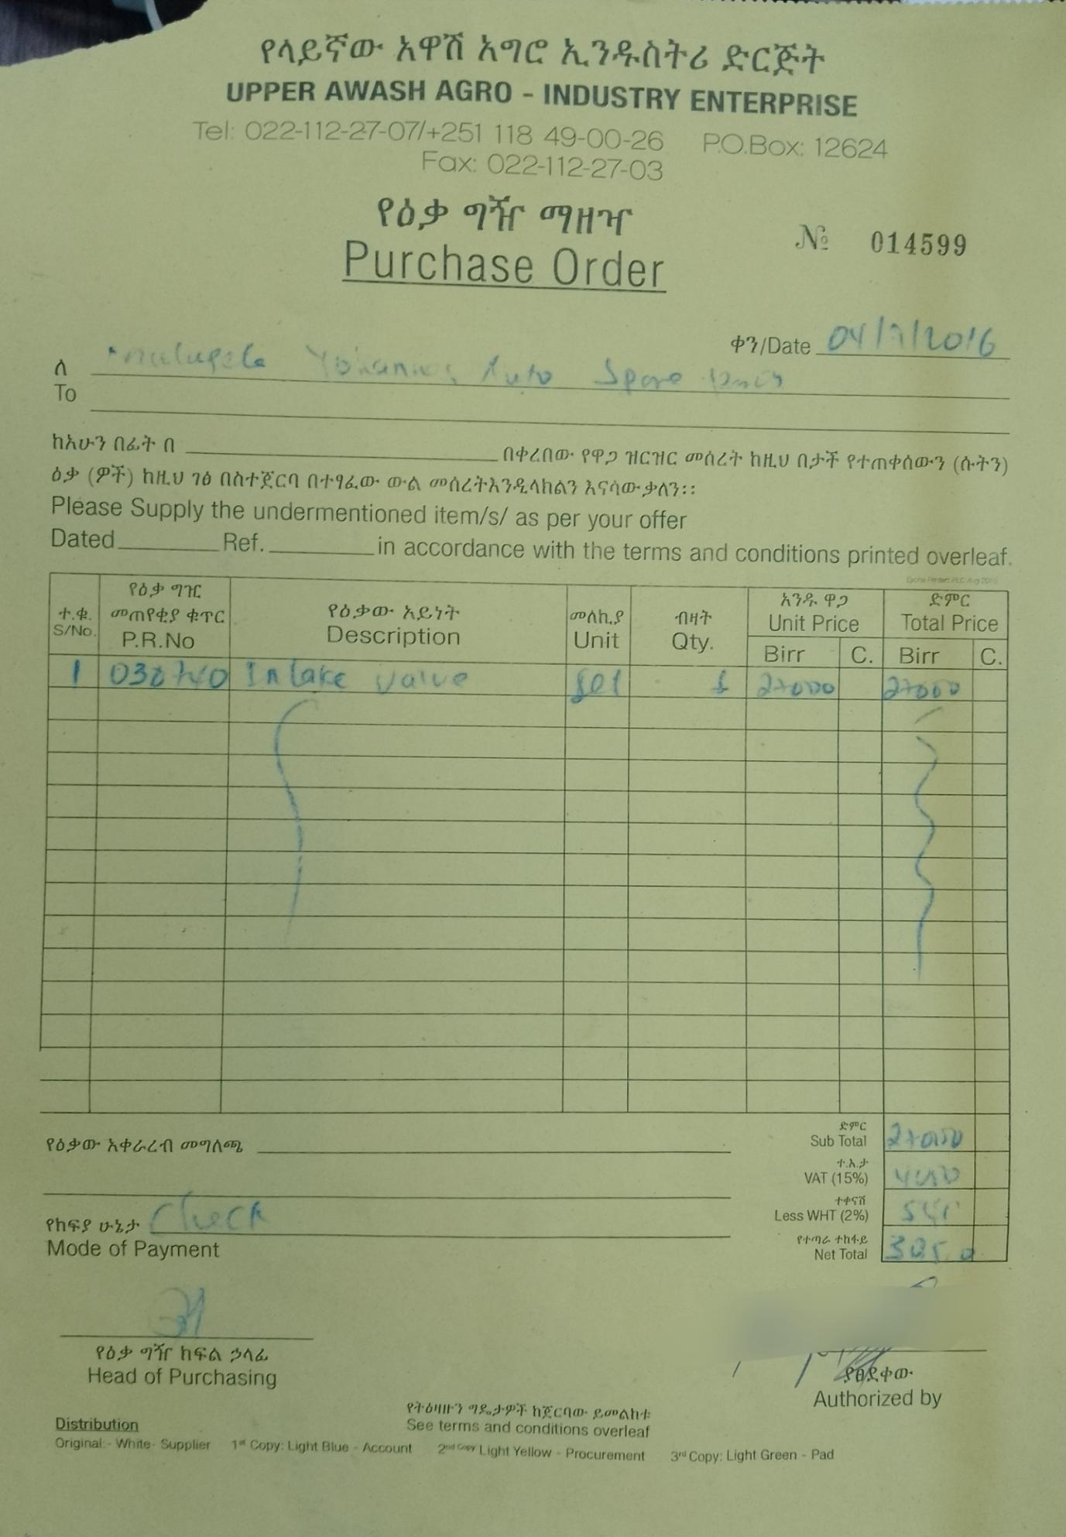

*Image 2. Purchase Order Form*

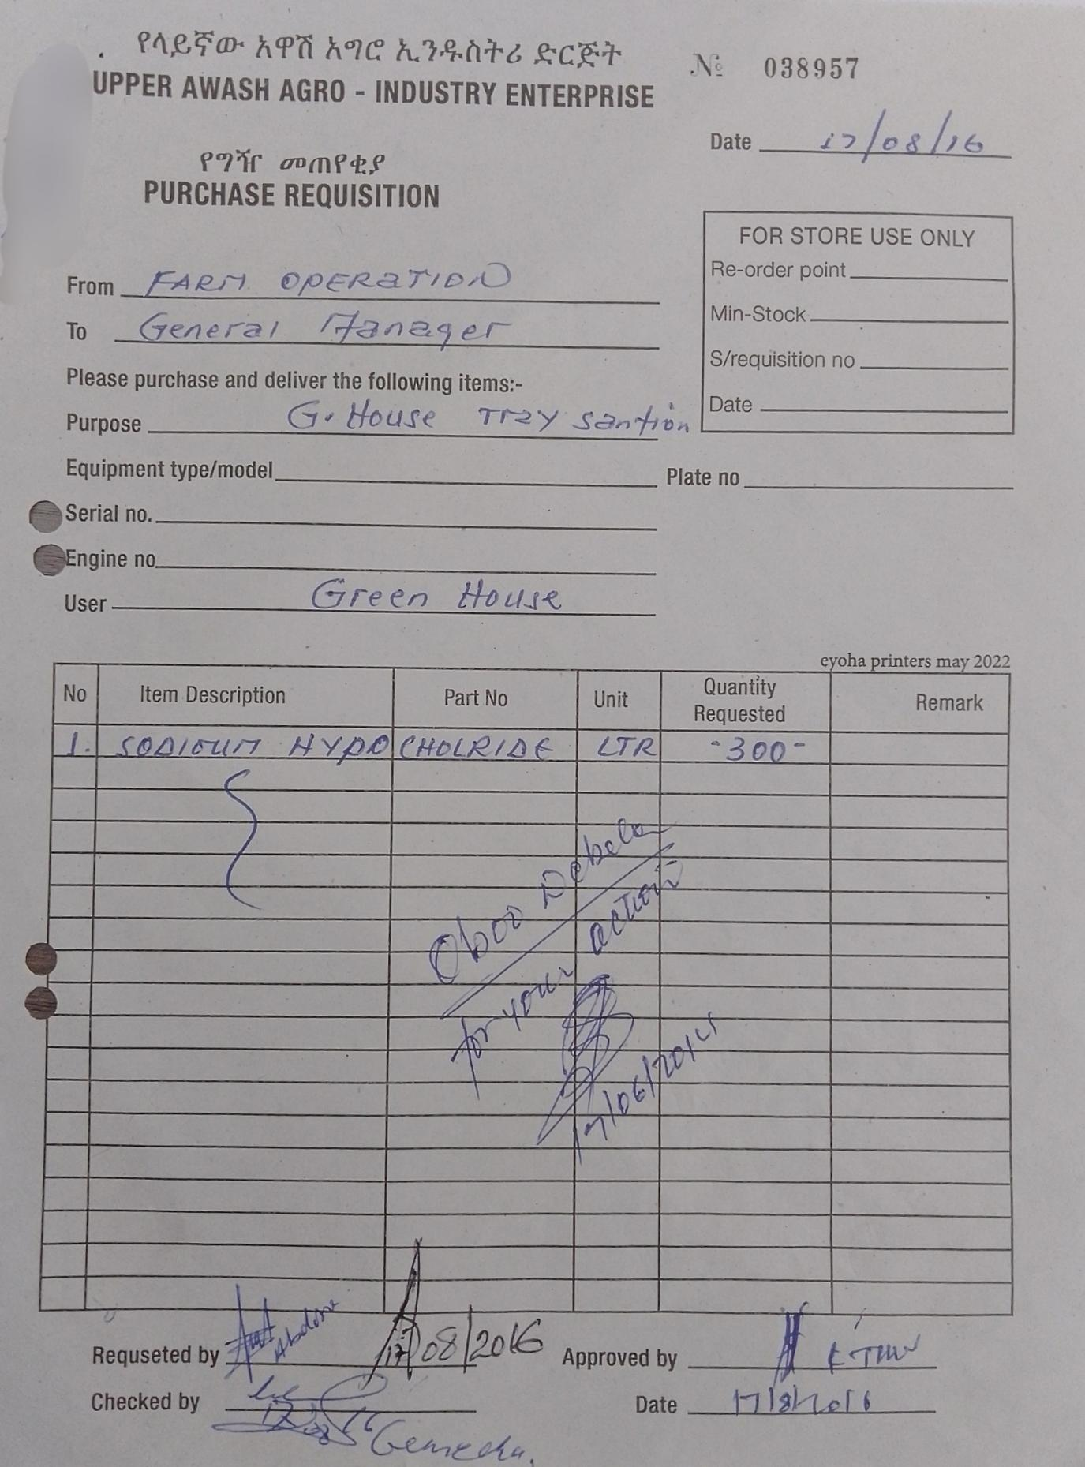

*Image 3. Purchase Requisition Form*

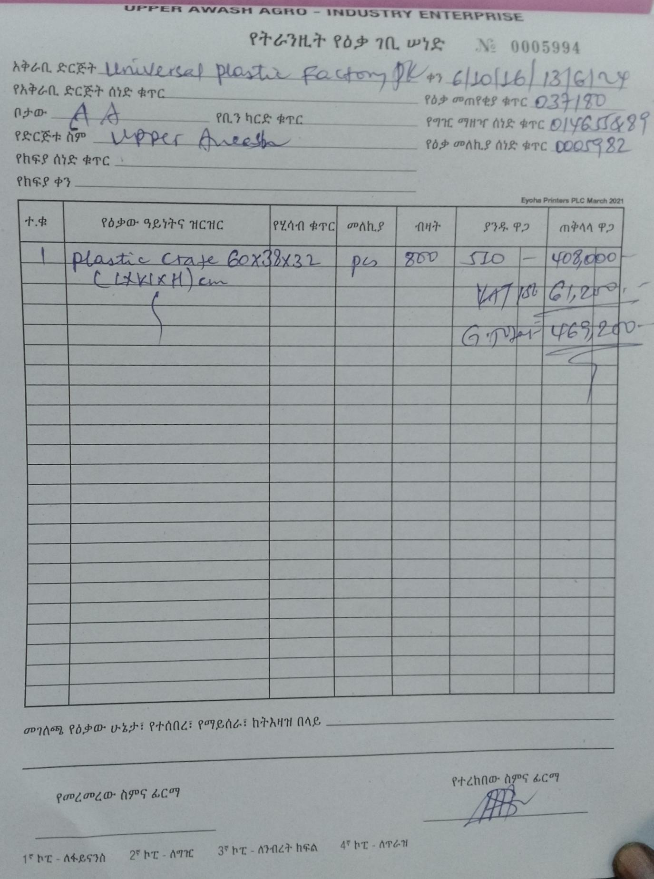

*Image 4. Goods In Transit Form*

* **Current System Forms:**
* Proforma Invoice Submission Form
* **Reports:**
* Procurement Status Report
* Supplier Performance Report
* Budget and Spending Analysis Report
* Audit Trail Report

## Requirement Gathering

### Requirement Gathering Techniques

To ensure the development of a system that aligns with Upper Awash Agro Industry’s needs, various requirement-gathering techniques were employed. These include:

* **Interviews:** Conducted with procurement staff, department heads, and suppliers to gain insights into pain points, expectations, and desired features.
* **Observation:** The project team observed the existing procurement process to identify inefficiencies and understand workflows.
* **Document Analysis:** Reviewed existing forms, purchase records, and communication logs to evaluate data volumes, error rates, and processing times.
* **Workshops:** Facilitated collaborative sessions with stakeholders to brainstorm solutions, validate requirements, and prioritize features.

By employing these techniques, we can ensured that the proposed system would address the organization’s current challenges while being user-friendly and adaptable to future needs.

## Methods of Communication

### Common Techniques

Effective communication is essential for the success of this project. The communication techniques employed include:

**Email and Messaging Platforms:** For sharing updates, documentation, and quick responses among stakeholders.

**Regular Meetings:** Holding verious meetings sessions with stakeholders, when they’re available, to review progress, address challenges, and ensure scope and functionality alignment.

**Workshops**: Organized to help us understand innerworkings of what a procurement process is and what that process intails, and make sure we are inline with the scope and dimention of those processes by communicating and brainstorming with the stakeholders and receive feedback.

## Requirement Definition

Requirement definiton is the process of identifying and documenting the specific needs, goals, and constraints of a project. This includes identifying the stakeholders and their requirement, as well as defining the functional and non-functional requirements of the project.

The purpose of requirement definition is to ensure that the project meets the needs of the stakeholders and delivers the desired outcome. It helpsto clarify the scope of the project and serve as a basis for the project.

### Functional Requirement

A Functional Requirement is a desription of a service the web app must offer. It describes the application system and it’s components. All functionalities that are listed and described in this section needs to be included in the system development because the system provides these functionalities as a service when the implementation is over.

* The system allows suppliers to register by providing necessary identification and business information.
* The system enables all users (Logistics and Supply Unit, Budget Control Unit, General Manager, Procurement Unit, Suppliers, Admin) to log in to their respective accounts using valid credentials, ensuring controlled access and authentication.
* The system allows the admin to create, edit, delete, and manage user accounts for all roles.
* The system allows suppliers to update their profile details, such as business name, contact information, and other relevant details.
* The system enables the Logistics and Supply Unit to create purchase requests by submitting item descriptions, quantities, urgency, and other required details.
* The system allows the General Manager to approve or deny purchase requests, ensuring compliance with organizational policies.
* The system enables the General Manager and the Budget Control Unit to leave comments on purchase requests for clarification or additional details.
* The system allows the Procurement Unit to post approved purchase requests as advertisements on the website for suppliers to view and bid on.
* The system enables suppliers to view available purchase request ads and place bids with detailed information, including prices and delivery timelines.
* The system allows the Procurement Unit to review submitted bids and award the bid to the most suitable supplier.
* The system allows the Procurement Unit to generate purchase orders after awarding a bid, ensuring that the order details are clearly communicated to the winning supplier.
* The system enables the Procurement Unit to generate a Goods Received Note (GRN) after verifying the receipt of goods or services from the supplier.
* The system allows the Procurement Unit to process and record payments for completed purchase orders.
* The system allows the General Manager and the Logistics and Supply Unit to track the progress of purchase requests, from creation to fulfillment.
* The system allows the admin to approve or reject supplier registrations to ensure that only legitimate suppliers are onboarded.
* The system allows the admin to ban suppliers in case of policy violations or poor performance, restricting them from accessing the platform.
* The system provides notifications to all relevant actors regarding updates on purchase requests, bids, approvals, and payments to ensure effective communication.
* The system maintains a detailed audit trail for purchase requests, approvals, bids, payments, and goods received, ensuring accountability and transparency.
* The system provides reports for purchase activities, including statistics on purchase requests, bids, approvals, and supplier performance, to help management make informed decisions.
* The system ensures security and confidentiality by limiting user access to sensitive data based on their roles and permissions.

In a simplified way we can represent the requerments as follows:

1. **Employee Side User Management (Logistics and Supply Unit):**
2. Login
3. Create Purchase Request
4. Track Progress
5. **Employee Side User Management (Budget Control Unit)**
6. Login
7. Leave a Comment
8. **Employee Side User Management (General Manager)**
9. Login
10. Approve Purchase Request
11. Deny Purchase Request
12. Leave a Comment
13. Track Progress
14. Ban Supplier
15. **Employee Side User Management (Procurement Unit)**
16. Login
17. Post Ads
18. Award Bid
19. Create Purchase Order
20. Create Goods Received Note
21. Make Payment
22. **Suppliers**
23. Register
24. Login
25. Update Profile
26. Place Bid
27. Issue Pick-up Date
28. **Admin**
29. Login
30. Create Account
31. Edit Account
32. Approve Account Registration
33. Delete Account
34. Ban Supplier

#### Essential Usecase Modeling

Essential usecases express the essence of what a software application or system must do to fulfill the goals of its users. Use case modeling identifies the key interactions between the system and its users, ensuring all functionalities are captured. Essential use cases include:

In the image below we see the stakeholders involved in the system and the basic functionalities they expect out of it.

**Essential Usecase Diagrams**

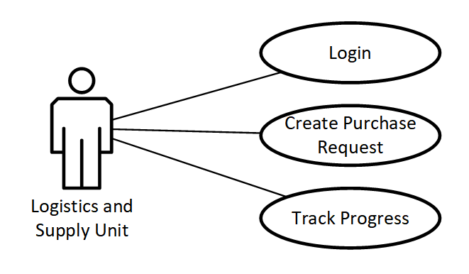

*Figure 1. Essential Usecase - Logistics and Supply Unit*

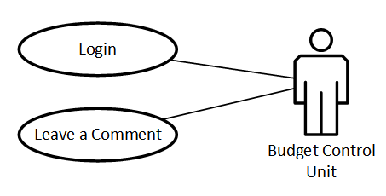

*Figure 2. Essential Usecase - Budget Control Unit*

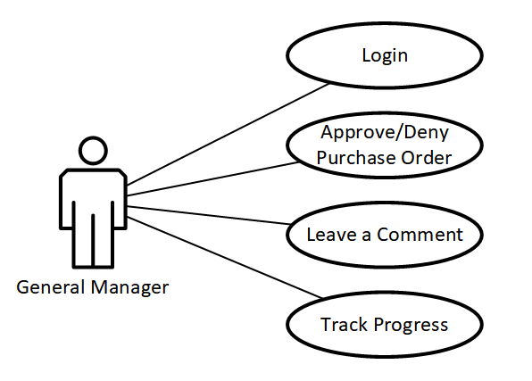

*Figure 3. Essential Usecase - General Manager*

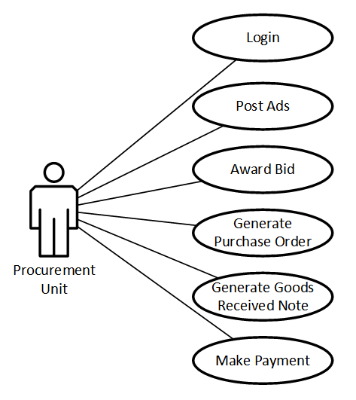

*Figure 4. Essential Usecase - Procurement Unit*

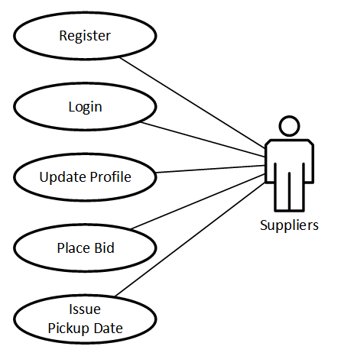

*Figure 5. Essential Usecase - Suppliers*

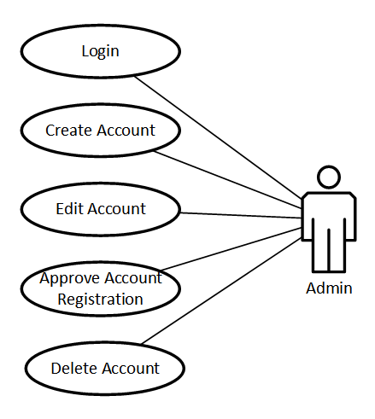

*Figure 6. Essential Usecase - Admin*

#### Actor Description

|  |  |  |
| --- | --- | --- |
| **ID** | **Actor Name** | **Description** |
| A01 | Supply and Logistics Unit | Generate purchase request when stock in inventory is running low or items requested are not in stock. |
| A01 | Budget Control Unit | Evaluate if the requested items are within budget and give comment |
| A03 | General Manager | Aprove or deny purchase requests |
| A04 | Procurement Unit | Post purchase request ads and start the procurement process |
| A05 | Suppliers | Provide their goods for the company |
| A06 | Administrator | Control and manage the overall system |

*Table 1. Actor Description*

**Supply and Logistics Unit:** In Upper Awash Agro Industry every purchase request is generated by these employees. They are commonly refered to as “Store employees” and are found on every processing plant, farm site, and branch offices. All materials and equipments are provided by them. Currently the company has a working inventory system which helps these employees manage stock but when they are running low on specific items they are responsible for managing the submission of purchase requests and ensuring they are accurate and complete before approval. They also follow up on the procurement process and ensure timely delivery of goods to the requesting departments.

**Budget Control Unit:** Ensures that purchase requests align with the allocated budget. They review requests for financial feasibility and compliance with the organization's budgetary policies. After evaluating, they attach their discovery with the request for the General Manger.

**General Manager:** Has the final authority to approve or reject purchase requests. The general manager ensures that procurement decisions align with the organization's strategic goals and operational priorities.

**Procurement Unit:** Handles the end-to-end procurement process, including posting purchase requests, obtaining proforma invoices, evaluating proforma invoices, generating purchase orders, awarding those orders, making payment, upon receiving the goods they generate goods received note, and also maintaining supplier relationships.

**Suppliers:** External entities that provide goods and services to the organization. They interact with the system to submit proforma invoices, receive purchase orders, and communicate with the procurement unit.

**Administrator:** Manages system configurations, user roles, and permissions. They ensure the system operates smoothly, handle technical issues, and oversee data security and integrity.

#### Essential Usecase Description

* **Register**: Users register or get regitered to they system so they can have role based acces to the system. This role based access allows and restricts them to only interact with functionalities of the system that’s required to them.
* **Login**: Enables authorized users to access the system with a valid username and password. Role-based permissions determine access to specific functionalities.
* **Create Purchase Request:** Logistics and Supply Unit users can submit detailed purchase requests, including item descriptions, quantities, and priorities. The system validates the request and forwards it for approval.
* **Post Ads on the Web:** Approved purchase requests are posted by the Procurement Unit as advertisements, inviting suppliers to place bids. This use case ensures that detailed request information is visible to all suppliers.
* **Place Bid:** Suppliers submit bids in response to posted advertisements, specifying prices, delivery timelines, and other terms. The system records and timestamps all bids.
* **Create Purchase Order:** The Procurement Unit generates purchase orders based on approved bids. The order includes supplier details, agreed prices, quantities, and delivery schedules.
* **Make Payment:** The Procurement Unit processes payments for completed and verified deliveries. The system generates payment records and tracks the transaction status.

#### Essential Usecase Interface Prototyping (Low Fidelity Prototyping)

### Collaboration Modeling

## Non-Functional Requirement

Non-functional features are aspects of this systems that define its characteristics and qualities, rather than specific functionalities. These features contribute to the overall performance, usability, and efficiency of the system. Here are some important non-functional features that are often expected in this system.

|  |  |
| --- | --- |
| **Non-Functional Requirement** | **Description** |
| **Scalability** | The ability to scale the e-PMS system to accommodate growing business needs, whether it's an increase in users, data volume, or transaction volume. |
| **Stability** | The system should quickly recover from failures or disruptions, maintaining data integrity and continuing to function correctly |
| **Performance** | * Responsive and efficient performance, even under heavyloads or peak times * Quick response times for user queries and transactions |
| **Reliability and Availability** | * High system reliability with minimal downtime * Ensured availability to support critical business operations24/7 |
| **Security** | * Robust data security measures to protect sensitiveinformation. * Access controls and user authentication to ensure dataintegrity |
| **Usability and User Experience** | * Intuitive user interfaces that are easy to navigate * User-friendly design to facilitate user adoption and reduce training time |
| **Data Management and**  **Integrity** | * Data consistency and accuracy across all modules * Data backup and recovery mechanisms to prevent data loss |
| **Flexibility and Customization** | * Ability to customize workflows, reports, and interfaces based on specific business needs * Support for changes in business processes without disrupting operations |
| **Mobile Accessibility** | Support for mobile devices to enable remote access and on- the-go functionality |
| **Training and Support** | Adequate training resources and support to assist users in utilizing the e-PMS system effectively |
| **Documentation** | Comprehensive documentation for administrators and users |

*Table 2. Non-Functional Requirement*

## System Modeling

### Introduction

This chapter covers the technical aspects of the proposed plant status tracking system and online marketplace, including the identification of the user interface (UI) and business rules. It discusses the design and implementation of the Android and Web UI, as well as the layout, navigation, and visual elements used to create an intuitive and user-friendly interface. Additionally, it highlights the guidelines and requirements that have been established to govern how the system operates and makes decisions, including scalability and flexibility, integration with other systems, and costeffectiveness. It also covers more technical aspects of the system such as Data modeling, use case modeling and Sequence diagrams.

Overall, this chapter provides an in-depth examination of the system modeling process for the proposed plant status tracking system and online marketplace. By understanding the above stated elements and how they interact with one another, it ensures that the system is designed to meet the needs of users and operates effectively and efficiently.

* + 1. System Use Case
    2. UI Identification
    3. Business Rules Identification
    4. Actor Identification
    5. Use Case Diagram

### Use Case Description

Usecase descriptions are more detailed than essential usecase descriptions and provide a comprehensive overview of the user’s taks and goals. They provide a step by step description of how a user can accomplish a certain task, and include details like pre-conditions, post-conditions, and alternate paths.

Below we’ll see these detailed descriptions:

|  |  |
| --- | --- |
| **Usecase Description - Register** | |
| **Usecase ID** | UID-01 |
| **Usecase Name** | Register |
| **Actor** | Supplier |
| **Pre-condition** | None |
| **Sequential row** | 1. The user selects registration 2. The system display registration interface 3. The user enters data to the form and submits it 4. The system takes the data and inserts it into the database 5. The system will show success message 6. Use case ends |
| **Alternative Flow** | If the user enters incorrect data the system suggests the user to enter correct data |
| **Post condition** | The system confirms registration with a "Registered successfully" message |

*Table 3. Usecase Description - Register*

|  |  |
| --- | --- |
| **Usecase Description - Create Account** | |
| **Usecase ID** | UID-02 |
| **Usecase Name** | Create Account |
| **Actor** | Admin |
| **Pre-condition** | The admin must be logged in with account management privileges |
| **Sequential row** | 1. The admin selects the "Create Account" option 2. The system displays an account creation form 3. The admin enters the new user's details and submits the form 4. The system validates and saves the new account 5. Use case ends |
| **Alternative Flow** | If entered details are not valid the system prompts the user to enter correct data |
| **Post condition** | The new account is successfully created and stored in the system |

|  |  |
| --- | --- |
| **Usecase Description - Login** | |
| **Usecase ID** | UID-03 |
| **Usecase Name** | Login |
| **Actor** | General Manager, Admin, Budget Control, Procurement Unit, Supply and Logistics Unit, Supplier |
| **Pre-condition** | User account must be registered in the system database |
| **Sequential row** | 1. The user opens the login interface. 2. The user enters email and password and login. 3. The system will validate ate the email and password. 4. The system display user interface 5. Use case ends |
| **Alternative Flow** | 1. If the user enters incorrect data   - The system suggests the user to enter correct data.   1. If the user exists but the password does not match   - The system suggests the user to enter correct password  - The system suggests user password recovery |
| **Post condition** | The user is successfully logged into the system and redirected to their respective dashboard |

|  |  |
| --- | --- |
| **Usecase Description - Create Purchase Request** | |
| **Usecase ID** | UID-04 |
| **Usecase Name** | Create Purchase Request |
| **Actor** | Supply and Logistics Unit |
| **Pre-condition** | The user must be logged in and have permission to create purchase requests |
| **Sequential row** | 1. The user selects the "Create Purchase Request" option 2. The system displays a form to input request details 3. The user enters details such as item description, quantity, and urgency 4. The system validates the input and submits the request to the database 5. The system displays a success message confirming the request submission 6. Use case ends |
| **Alternative Flow** | If the user enters invalid or incomplete data the system prompts the user to correct the input and resubmit. |
| **Post condition** | The purchase request is successfully created and added to the system. |

|  |  |
| --- | --- |
| **Usecase Description - Approve Purchase Request** | |
| **Usecase ID** | UID-05 |
| **Usecase Name** | Approve Purchase Request |
| **Actor** | General Manager |
| **Pre-condition** | The purchase request must exist and the user must be logged in with the required approval permissions. |
| **Sequential row** | 1. The user selects a purchase request for review 2. The system displays the request details 3. The user chooses to approve the request and optionally adds a comment 4. The system updates the status of the request in the database 5. The system notifies relevant actors about the decision. 6. Use case ends. |
| **Alternative** | None |
| **Post condition** | The purchase request is updated to reflect the approval decision. |

|  |  |
| --- | --- |
| **Usecase Description - Deny Purchase Request** | |
| **Usecase ID** | UID-06 |
| **Usecase Name** | Deny Purchase Request |
| **Actor** | General Manager |
| **Pre-condition** | The purchase request must exist and the user must be logged in with the required approval permissions. |
| **Sequential row** | 1. The user selects a purchase request for review 2. The system displays the request details 3. The user chooses to approve the request and optionally adds a comment 4. The system updates the status of the request in the database 5. The system notifies relevant actors about the decision 6. Use case ends |
| **Alternative Flow** | If the user didn’t fill in a comment to give a reason for the denial, the system will prompt to fill the field and resubmit |
| **Post condition** | The purchase request is returned to the Supply and Logistics unit with the comment |

|  |  |
| --- | --- |
| **Usecase Description - Post Ads** | |
| **Usecase ID** | UID-07 |
| **Usecase Name** | Post Ads |
| **Actor** | Procurement Unit |
| **Pre-condition** | The purchase request must be approved, and the user must be logged in with procurement privileges. |
| **Sequential row** | 1. The user selects an approved purchase request 2. The system displays a template for posting ads 3. The user reviews and customizes the ad details 4. The system posts the ad to the website 5. The system confirms the ad has been successfully posted 6. Use case ends |
| **Alternative Flow** | If the user decides the request should be processed in a diferent procedure (i.e. Contracted companies and manufacturers, Imported goods, open auction) then they will proceed on a different avenue |
| **Post condition** | The ad for the approved purchase request is visible to suppliers on the website. |

|  |  |
| --- | --- |
| **Usecase Description - Place Bid** | |
| **Usecase ID** | UID-08 |
| **Usecase Name** | Place Bid |
| **Actor** | Suppliers |
| **Pre-condition** | The supplier must be registered, logged in, and able to view purchase request ads |
| **Sequential row** | 1. The supplier browses available ads 2. The supplier selects an ad and clicks "Place Bid." 3. The system displays a bid submission form 4. The supplier fills in bid details and submits 5. The system records the bid in the database and displays a confirmation message 6. Use case ends |
| **Alternative Flow** | If the supplier submits incomplete or invalid bid details the system prompts corrections before accepting the bid |
| **Post condition** | The bid is successfully submitted and stored in the system for evaluation. |

|  |  |
| --- | --- |
| **Usecase Description - Award Bid** | |
| **Usecase ID** | UID-09 |
| **Usecase Name** | Award Bid |
| **Actor** | Procurement Unit |
| **Pre-condition** | Bids must exist for the relevant purchase request, and the user must have the necessary permissions |
| **Sequential row** | 1. The user reviews submitted bids. 2. The system displays all relevant bid details. 3. The user selects the winning bid and awards it. 4. The system updates the status of the purchase request and notifies the winning supplier. 5. Use case ends. |
| **Alternative Flow** | None |
| **Post condition** | The bid is successfully awarded, and the supplier is notified. |

|  |  |
| --- | --- |
| **Usecase Description - Track Progress** | |
| **Usecase ID** | UID-10 |
| **Usecase Name** | Track Progress |
| **Actor** | Procurement Unit, Logistics and Supply Unit, General Manager |
| **Pre-condition** | The user must have submitted or approved a purchase request and be logged in |
| **Sequential row** | 1. The user selects the "Track Progress" option 2. The system displays a list of active purchase requests 3. The user selects a specific request to view detailed progress (e.g., approval status, bid status) 4. Use case ends |
| **Alternative Flow** | None |
| **Post condition** | The user successfully views the current status of the purchase request |

|  |  |
| --- | --- |
| **Usecase Description - Leave a Comment** | |
| **Usecase ID** | UID-11 |
| **Usecase Name** | Leave a Comment |
| **Actor** | Procurement Unit, Logistics and Supply Unit, General Manager |
| **Pre-condition** | The user must have submitted or approved a purchase request and be logged in |
| **Sequential row** | 1. The user selects the "Track Progress" option    1. Budget Control Unit selects “Purchase Requests List” option 2. The system displays a list of active purchase requests 3. The user selects a specific request to view the detail of 4. The user leaves a comment in the specified location 5. Use case ends |
| **Alternative Flow** | None |
| **Post condition** | The user successfully views the current status of the purchase request |

|  |  |
| --- | --- |
| **Usecase Description - Create Purchase Order** | |
| **Usecase ID** | UID-12 |
| **Usecase Name** | Create Purchase Order |
| **Actor** | Procurement Unit |
| **Pre-condition** | The bid must be awarded, and the user must be logged in with procurement permissions. |
| **Sequential row** | 1. The user selects an awarded bid 2. The system displays the details of the awarded bid 3. The user creates a purchase order by confirming the details 4. The system saves the purchase order and notifies the supplier 5. Use case ends |
| **Alternative Flow** | None |
| **Post condition** | The purchase order is successfully generated and stored in the system. |

|  |  |
| --- | --- |
| **Usecase Description - Create Goods Received Note** | |
| **Usecase ID** | UID-13 |
| **Usecase Name** | Create Goods Received Note |
| **Actor** | Procurement Unit |
| **Pre-condition** | The goods or services must have been received, and the user must be logged in with procurement privileges |
| **Sequential row** | 1. The user selects a completed purchase order 2. The system displays the purchase order details 3. The user verifies the received goods/services and generates a goods received note 4. The system saves the note and updates the purchase order status 5. Use case ends |
| **Alternative Flow** | None |
| **Post condition** | The goods received note is successfully generated and stored in the system |

|  |  |
| --- | --- |
| **Usecase Description - Make Payment** | |
| **Usecase ID** | UID-14 |
| **Usecase Name** | Make Payment |
| **Actor** | Procurement Unit |
| **Pre-condition** | The goods or services must have been received, and the user must be logged in with payment permissions |
| **Sequential row** | 1. The user selects a completed purchase order with a goods received note 2. The system displays the payment details 3. The user confirms and processes the payment 4. The system records the payment and notifies the supplier 5. Use case ends |
| **Alternative Flow** | None |
| **Post condition** | The payment is successfully processed, and the supplier is notified |

|  |  |
| --- | --- |
| **Usecase Description - Delete Account** | |
| **Usecase ID** | UID-15 |
| **Usecase Name** | Delete Account |
| **Actor** | Admin |
| **Pre-condition** | The admin must be logged in and the account to be deleted must exist |
| **Sequential row** | 1. The admin selects the "Delete Account" option 2. The system displays a list of accounts 3. The admin selects an account to delete 4. The system prompts for confirmation 5. The admin confirms, and the system removes the account 6. Use case ends |
| **Alternative Flow** | None |
| **Post condition** | The account is successfully deleted from the system |

|  |  |
| --- | --- |
| **Usecase Description - Ban Supplier** | |
| **Usecase ID** | UID-16 |
| **Usecase Name** | Ban Supplier |
| **Actor** | Admin, General Manager |
| **Pre-condition** | The supplier must be registered in the system, and the user must be logged in with banning privileges |
| **Sequential row** | 1. The user selects the "Suppliers" option 2. The system displays a list of registered suppliers 3. The user selects a specific supplier 4. The system displays details about that specific supplier 5. The user selects “Ban Supplier” option 6. The system prompts for confirmation with a reason for the ban 7. The admin confirms the action and submits the ban request 8. The system updates the supplier's status to "Banned" and notifies the supplier of the action 9. Use case ends |
| **Alternative Flow** | If the admin attempts to ban a non-existent, un-approved or already banned supplier, the system displays an error message |
| **Post condition** | The supplier's account is banned, restricting them from accessing the system or placing bids. |

* + 1. Sequence diagramming
    2. Activity Diagramming
    3. Class diagram
    4. State chart diagram